Queen’s University Postgraduate Research Student Personal Development Planner

This document has been designed to help you to assess your development needs and to plan appropriate training and development activity in support of those needs. The planner is derived from the Researcher Development Framework, a tool that supports the personal, professional and career development of researchers. The planner can be used as a record of your training and development, for use when speaking to employers or in academic reviews.

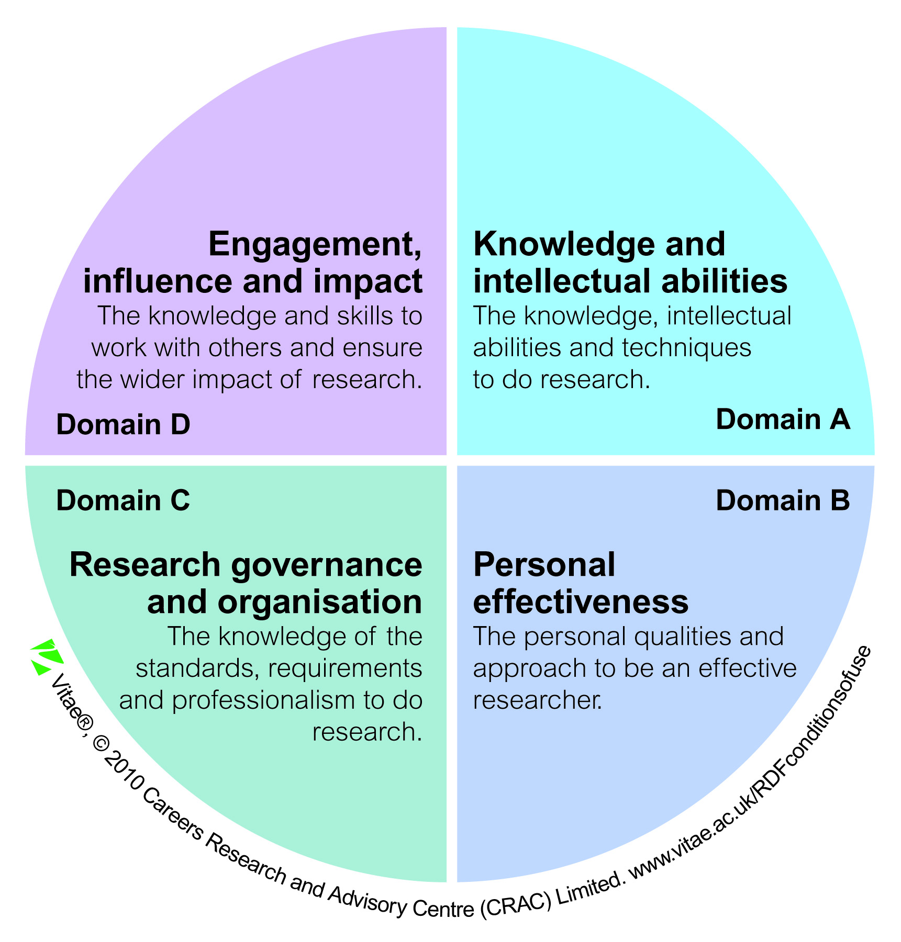
With your supervisor, you can discuss the particular domains and sub-domains that you have an interest in developing. These are likely to change throughout the course of your research degree.

It is useful to agree specific development needs alongside the learning approaches you will take to support your development. For examples of different training and development approaches and support provided within the Postgraduate Researcher Development Programme, visit the PRDP web-site (www.qub.ac.uk/pstp).

Whilst your supervisor can support your skills development, you will need to ‘take the lead’ with regard to this area of your research degree.

Should you require support in using the form or in identifying your development needs, contact the PRDP Training Team (pg.training@qub.ac.uk).

2011/Postgraduate Research Student Personal Development Planner/version 1

Domain A: Knowledge and intellectual abilities
Sub-domain | Sub-domain summary | Development needs and how they will be met | Timeline | When completed and any additional comments
Knowledge Base | Knowledge of:  - The area of research, the advances within it and its relationships with other research areas  - The methods and experimental techniques appropriate for research design  - Sources of information, bibliographic software and other information technologies  - Literacy and numeracy skills and language abilities appropriate for research  Behaviour:  - Makes original contributions to knowledge  - Identifies, applies and develops methods and experimental techniques appropriate for research projects  - Conducts effective and comprehensive information searches  - Records, manages and handles information/data using appropriate bibliographic software and other information technologies
Cognitive Abilities | Behaviour:  - Analyses and evaluates findings using appropriate methods  - Thinks originally, independently and critically; develops theoretical concepts  - Critically synthesises information from diverse sources  - Evaluates progress, impact and outcomes of research  - Recognises and validates problems; formulates and applies solutions to a range of research problems  Attitude:  - Willing to give and receive constructive criticism
Creativity | Behaviour:  - Develops new ways of working; has novel ideas and realises their potential  - Identifies new trends; creates new opportunities  - Develops convincing and persuasive arguments to defend research  - Takes intellectual risks; challenges the status quo  Attitude:  - Takes a creative, imaginative and inquiring approach to research  - Is open to new sources of ideas

Domain B: Personal Effectiveness
Sub-domain | Sub-domain summary | Development needs and how they will be met | Timeline | When completed and any additional comments
Personal Qualities | Attitude:  - Approaches research with enthusiasm, passion and confidence  - Is resilient and perseveres in the face of obstacles  - Is self-reflective; seeks ways to improve performance and strives for research excellence  - Is pro-active, independent, self-reliant and takes responsibility for self and others  - Shows integrity
Self-Management | Behaviour:  - Anticipates and responds to directions and trends in research  - Plans, prioritises and conducts research in proactive way  - Delivers research projects and results on time and effectively  - Develops awareness of, and helps to achieve, work-life balance for self and colleagues  Attitude:  - Has a strategic approach to research  - Has focus, commitment and ambition  - Is flexible and responsive to change
Professional and Career Development | Knowledge of:  - Career and employment opportunities inside and outside academia  Behaviour:  - Takes ownership of and manages professional development  - Shows commitment to continuing professional development and enhancing employability  - Maintains and develops relevant skills set and experience in preparation for a wide range of opportunities within and outside academia  - Actively networks for professional and career purposes and seeks to enhance research reputation and esteem

Domain C: Research Governance and Organisation
Sub-domain | Sub-domain summary | Development needs and how they will be met | Timeline | When completed and any additional comments
Professional Conduct | Knowledge of:  - Health and safety issues, confidentiality and ethical requirements of his/her research field  - The legal requirements and regulations relating to the area of research and the research environment  - The principles of intellectual property rights (IPR) and copyright issues, as they relate to research, its commercialisation and dissemination  - Organisational and professional requirements and environmental impact of research  - The concept of corporate social responsibility  Behaviour:  - Respects, acknowledges and attributes the contribution of others  - Seeks to protect, where appropriate, the intellectual assets arising from research and to maximise the wider value of research findings  - Acts with professional integrity in all aspects of research governance  - Uses institutional/organisational resources responsibly and appropriately  - Seeks ways of working in a sustainable manner  Attitude:  - Respects, upholds and meets professional standards and requirements
Research Management | Knowledge of:  - The contribution of research to the health of disciplines and institutional missions  - Project management tools and techniques  Behaviour:  - Applies appropriate project management tools and techniques  - Sets goals and plans and manages resources to deliver results  - Effectively assesses and manages risks  - Evaluates the effectiveness of research projects
Finance, funding and resources | Knowledge of:  - The requirement for research income generation and financial management  - Mechanisms for funding, the range of funding sources and the processes for making applications  - Local administrative systems, reporting procedures and infrastructure processes  Behaviour:  - Responsibly manages finances, resources and infrastructures related to research

Domain D: Engagement, influence and impact
Sub-domain | Sub-domain summary | Development needs and how they will be met | Timeline | When completed and any additional comments
Working with others | Behaviour:  - Actively works in an inclusive, respectful and constructive way with colleagues, stakeholders and research users  - Recognises and acknowledges the contribution of others and own part in team success  - Builds relationships in academic and commercial contexts; approachable and interacts constructively with others; manages expectations and resolves conflict  - Supervises, mentors and develops the potential of less experienced researchers and colleagues through support and advice  - Leads, motivates and influences where appropriate; persuades through listening and convincing discussion  - Builds and sustains collaborative relationships and works pro-actively to create and develop knowledge with a range of stakeholders, including researchers, funders and users  - of research  Attitude:  - Respects the inclusive and collegial manner in which researchers conduct relationships within and beyond academia  - Recognises the potential for working in sustained partnerships with a range of stakeholders to generate new ideas, insights and maximise the potential for wider societal and  - economic impact  - Respects individual difference and diversity
Communication and dissemination | Knowledge of:  - Appropriate communication and dissemination mechanisms for different audiences  - The importance of engaging in the processes of publication and dissemination of research results and impacts  Behaviour:  - Communicates effectively in both written and oral modes with a range of audiences formally and informally through a variety of different techniques and media  - Actively engages in publication and dissemination of research results and impacts
Engagement and Impact | Knowledge of:  - Global, organisational, cultural, economic, and environmental contexts, and the wider impact of research  - The social and ethical implications of research, and public attitudes to these issues  - The range of mechanisms to support knowledge transfer and maximise the impact of research in academic, economic and societal contexts  Behaviour:  - Engages with and shares research through research-informed and student-focused teaching  - Contributes to increasing public awareness, engagement and understanding of research and associated impacts  - Identifies innovative trends, ideas and applications; is enterprising and entrepreneurial within and beyond academia  - Works collaboratively with all stakeholders to create, develop and exchange research knowledge to influence and benefit policy development, society and the economy;  - seeks new outlets and promotes the application of research in innovative ways  - Appreciates and works with diversity and difference in research and education  Attitude:  - Values the contribution of research to teaching and teaching to research  - Recognises the importance of accountability of research with regard to social and economic impacts, internationalisation and global citizenship

